

# Seminar Report on

# *Role of AI in Education*

# By

*Aaron Philip*

*1032210163*

*Under the guidance of*

*Dr. Vaishali Suryawanshi*

**Dr. Vishwanath Karad MIT-World Peace University**

**Department of Computer Engineering & Technology School of Computer Science & Engineering**

**\* 2023-2024\***



**Dr. Vishwanath Karad MIT-World Peace University (MIT-WPU) School of Computer Science & Engineering CERTIFICATE**

This is to certify that Mr. Aaron Philip of B. Tech CSE, Semester-VI, PRN. No. 1032210163, has successfully completed seminar on

*Role of AI in Education*

This seminar is satisfactorily submitted & delivered during the academic year 2023-2024 towards the partial fulfillment of degree of Bachelor of Computer Science Engineering under Dr. Vishwanath Karad MIT- World Peace University, Pune.

Dr. Vaishali Suryawanshi

Dr. Balaji Patil

Seminar Guide Name & Sign Program Director Department of CET, SoCSE

Date & Place:

**List of Figures**

1. Experimental Work System Architecture (Pg. 7)
2. Dong, C. (2021). How to Build an AI Tutor that Can Adapt to Any Course and Provide Accurate Answers Using Large Language Model and Retrieval-Augmented Generation. (Pg. 9)
3. Borchers, C., Wang, Y., Karumbaiah, S., Ashiq, M., Shaffer, D. W., & Aleven, V. (2021). Revealing Networks: Understanding Effective Teacher Practices in AI-Supported Classrooms using Transmodal Ordered Network Analysis (Pg. 12)
4. Mangotra, H., Dabas, V., Khetharpal, B., Verma, A., Singhal, S., & Mohapatra, A. K. University Auto Reply FAQ Chatbot Using NLP and Neural Networks. (Pg. 15)
5. Singh, Y., Kumar, R., Kabdal, S., & Upadhyay, P. (2023). YouTube Video Summarizer using NLP: A Review. International Journal of Performance Evaluation, vol. 19, no. 12, December 2023 (Pg. 19)
6. Experimental Work (Pg. 26)

**List of Tables.**

1. Performance evaluation using guided techniques (Pg. 21)
2. Model Differences (Pg. 25)

**Acknowledgement**

I, Aaron Philip (PRN: 1032210163), would like to extend my sincere gratitude to Dr. Vaishali Suryawanshi, my esteemed seminar guide, for her invaluable support, guidance, and encouragement throughout the preparation and presentation of this seminar. Her expertise has been instrumental in shaping the content and direction of this Seminar. I am deeply grateful for her unwavering commitment and dedication, which have greatly enriched my understanding and perspective on this vital topic. Thank you Ma’am, for your mentorship and inspiration. Additionally, I extend my heartfelt appreciation to Dr Mangesh Bedekar, the Dean of the Department of Computer Engineering and Technology, for his unwavering support and encouragement throughout the journey of preparing and presenting this seminar. His guidance has been invaluable in shaping the direction of my work, and I am deeply thankful for his mentorship. I would also like to express my sincere thanks to Dr. Balaji Patil, the Program Director, for his continuous support and valuable insights which have contributed significantly to the success of this seminar. His expertise has been instrumental in enhancing the quality of my presentation. Furthermore, I am grateful to the college administration for providing the necessary infrastructure and resources, without which this seminar would not have been possible. Their support has been pivotal in facilitating a conducive environment for academic pursuits. Last but not least, I extend my gratitude to my classmates for their unwavering support and encouragement throughout this endeavor. Their camaraderie has been a source of motivation, and I am grateful for their solidarity. Thank you all for your contributions towards making this seminar a success.

**Index**

|  |  |  |
| --- | --- | --- |
| **Sr. No.** | **Topic Name** | **Page Number** |
|  | Abstract & Keywords | 5 |
|  | Introduction | 6 |
|  | Literature Survey | 7-21 |
|  | Analytical, Experimental work | 22 |
|  | Details of Technology | 23-26 |
|  | Conclusion | 27 |
|  | References | 28 |
|  | Plagiarism Check | 29 |
|  | Appendix | 30 |
|  | Publication | 31 |

**Abstract**

Artificial Intelligence (AI) stands as a transformative force in education, reshaping traditional learning paradigms and offering unprecedented opportunities to enrich educational experiences. In this abstract, we delve into the multifaceted role of AI in education, exploring its potential to revolutionize teaching methodologies, cater to diverse learning needs, and pave the way for a more inclusive and effective learning environment. By harnessing AI-driven tools and technologies, educators can create personalized learning journeys tailored to individual student preferences, abilities, and pace. Adaptive assessments powered by AI enable real-time feedback and adjustment, ensuring that learners receive targeted support and interventions when needed. Moreover, AI fosters inclusivity by providing accommodations and support for students with varying learning styles and abilities, thereby creating a more equitable educational ecosystem. This abstract highlights the transformative impact of AI in education, emphasizing its capacity to optimize instructional practices, promote student-centered learning, and empower learners to thrive in the digital age.

**Keywords**

AI, Education, Personalized Learning, Adaptive Assessments, Intelligent Tutoring Systems

**Introduction**

In the realm of education, Artificial Intelligence (AI) stands as a transformative force, reshaping traditional learning paradigms. As we navigate the complexities of the digital age, AI has emerged as a powerful ally, offering unprecedented opportunities to enhance educational experiences. From personalized learning journeys to adaptive assessments, AI is redefining how we acquire and apply knowledge. This introduction delves into the multifaceted role of AI in education, exploring its potential to revolutionize teaching methodologies, cater to diverse learning needs, and pave the way for a more inclusive and effective learning environment. In today's educational landscape, Artificial Intelligence (AI) emerges as a pivotal catalyst, challenging conventional teaching norms. Its integration offers an array of novel possibilities, spanning personalized learning paths tailored to individual needs, dynamic assessments for real-time feedback, and an inclusive atmosphere fostering equity and engagement. This introduction illuminates AI's transformative potential, reshaping education for the digital era. In addition to reshaping learning paradigms and redefining teaching methodologies, AI plays a crucial role in promoting equity and inclusivity in education. By offering personalized learning paths tailored to individual needs, AI ensures that all students have access to high-quality education regardless of their backgrounds or abilities. Moreover, dynamic assessments powered by AI provide real-time feedback, allowing educators to address students' learning gaps promptly and effectively. As AI becomes more integrated into the educational landscape, it not only challenges traditional teaching norms but also opens up new avenues for collaboration, innovation, and engagement among students and educators alike. Ultimately, this introduction highlights AI's transformative potential in shaping education for the digital era and underscores the importance of leveraging technology to create a more equitable and effective learning environment.

The introduction sets the stage for an exploration of Artificial Intelligence (AI)'s transformative impact on education, emphasizing its role in reshaping traditional learning paradigms and fostering inclusivity. It highlights AI's potential to revolutionize teaching methodologies and cater to diverse learning needs, offering personalized learning paths and dynamic assessments for real-time feedback. As AI becomes more integrated into education, it not only challenges conventional teaching norms but also fosters collaboration, innovation, and engagement among students and educators. This introduction lays the groundwork for the subsequent sections of the report, which will delve into a comprehensive literature survey, analytical and experimental work, technology details, conclusions, references, and potential appendices. The report will follow this architecture shown below to delve deeper into the multifaceted role of AI in education, ultimately aiming to provide insights into its transformative potential for the digital era.

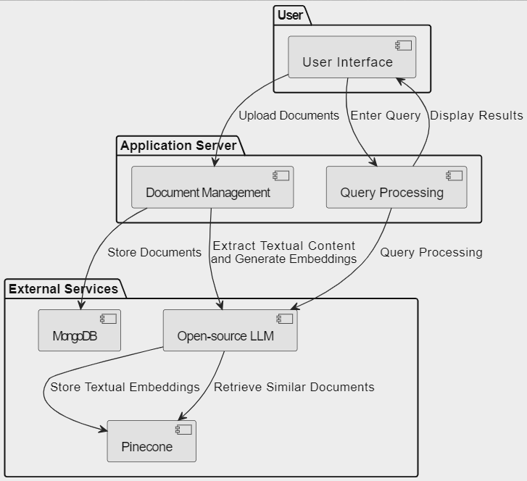

Experimental Work System Architecture

**Literature Survey**

In AI-driven educational advancements, a multitude of innovative approaches have emerged, as evidenced by a comprehensive survey of recent literature. One such groundbreaking study by Dong (2021) introduces AI Tutor, a cutting-edge web application designed to revolutionize personalized learning. Leveraging state-of-the-art Large Language Models (LLMs) and Retrieval-Augmented Generation (RAG) techniques, AI Tutor constructs adaptive knowledge bases tailored to specific courses, offering students detailed, conversational responses to their inquiries. This pioneering work sets the stage for democratizing access to high-quality educational support. Furthermore, Borchers et al. (2021) delve into the intersection of AI and effective teaching practices. Through transmodal ordered network analysis, the study uncovers insights into how teacher behaviors influence student learning outcomes in AI-supported classrooms, advancing our understanding of pedagogical strategies in the digital age. Complementing these advancements in personalized learning and classroom analytics, Mangotra et al. (2023) propose a Deep Learning Chatbot tailored to address common queries among university students. Meanwhile, Gowriraj et al. (2023) explore the performance of multilingual pretrained transformer models in document-grounded dialogue tasks. Through an evaluation of language-agnostic approaches and the effectiveness of query rewriting using large language models like ChatGPT, the study sheds light on optimizing multilingual document-grounded question answering systems. Expanding the scope beyond traditional educational platforms, Singh et al. (2023) delve into YouTube video summarization utilizing NLP techniques. Their review paper provides a comprehensive overview of the field, emphasizing the critical role of NLP in condensing vast amounts of multimedia content. Collectively, these studies underscore the transformative potential of AI in education, ranging from personalized tutoring systems and classroom analytics to student support mechanisms and multimedia content summarization. As the educational landscape continues to evolve, these innovative approaches pave the way for more accessible, effective, and engaging learning experiences.

**Research Paper 1**

**How to Build an AI Tutor that Can Adapt to Any Course and Provide Accurate Answers Using Large Language Model and Retrieval-Augmented Generation**

**Author(s): Dong Chenxi**

**1.1 Abstract**

Artificial intelligence is transforming education through data-driven, personalized learning solutions. This paper introduces AI Tutor, an innovative web application that provides personalized tutoring in any subject using state-of-the-art Large Language Model (LLM). AI Tutor ingests course materials to construct an adaptive knowledge base tailored to the course. When students pose questions, it retrieves the most relevant information and generates detailed, conversational responses citing supporting evidence. The system is powered by advanced large language models and Retrieval-Augmented Generation (RAG) techniques for accurate, natural question answering. We present a fully-functional web interface and video demonstration that showcase AI Tutor's versatility across diverse subjects and its ability to produce pedagogically cogent responses. While an initial prototype, this work represents a pioneering step toward AI-enabled tutoring systems that can democratize access to high-quality, customized educational support.

**1.2 Methodology**

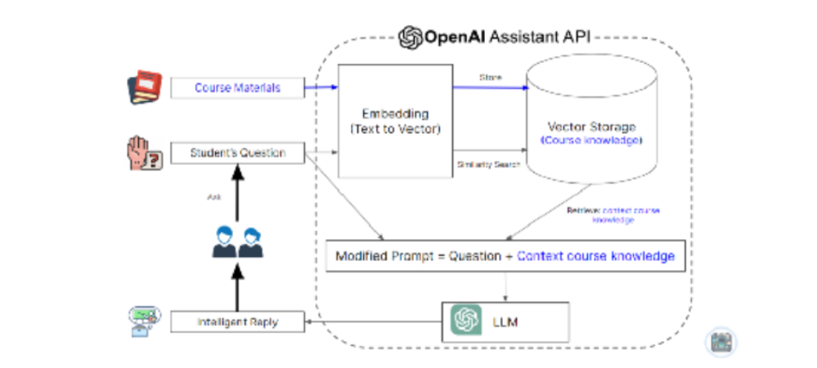

Figure 2 - Dong, C. (2021). How to Build an AI Tutor that Can Adapt to Any Course and Provide Accurate Answers Using Large Language Model and Retrieval-Augmented Generation.

**1.3 Summary**

This paper presents an innovative AI Tutor web application designed to revolutionize personalized tutoring across various subjects. Leveraging cutting-edge Large Language Model (LLM) technology, the platform employs sophisticated algorithms to deliver precise and natural question answering capabilities. By systematically analysing and processing course materials, the AI Tutor constructs an adaptive knowledge base uniquely tailored to each course's content and learning objectives. Through this approach, students benefit from a dynamic learning experience that seamlessly adapts to their individual needs and learning pace. The AI Tutor represents a significant advancement in educational technology, offering a scalable and efficient solution for enhancing student comprehension and mastery across diverse academic disciplines.

**1.4 Limitations**

The techniques used in the project, namely the LLM and the RAG, also have some limitations and challenges that need to be considered. One of the limitations is that the LLM and the RAG are computationally expensive and require a lot of resources and time to train and run. This may pose a challenge for the scalability and affordability of the AI tutor, especially for low-resource settings or large-scale applications. Another limitation is that the LLM and the RAG are based on statistical models and probabilistic methods, which may not capture the full complexity and diversity of natural language and human knowledge. This may result in some limitations in the expressiveness, interpretability, and explainability of the AI tutor’s answers. Moreover, the LLM and the RAG are still subject to some biases and errors that may affect the quality and reliability of the AI tutor’s answers. For example, the LLM may inherit some social or cultural biases from the training data, or the RAG may retrieve some irrelevant information from the external data source some times.

**Research Paper 2**

**How to Build an AI Tutor that Can Adapt to Any Course and Provide Accurate Answers Using Large Language Model and Retrieval-Augmented Generation**

**Author(s): Conrad Borchers, Yeyu Wang, Shamya Karumbaiah, Muhammad Ashiq, David Williamson Shaffer, Vincent Aleven**

**2.1 Abstract**

Learning analytics research increasingly studies classroom learning with AI-based systems through rich contextual data from outside these systems, especially student-teacher interactions. One key challenge in leveraging such data is generating meaningful insights into effective teacher practices. Quantitative ethnography bears the potential to close this gap by combining multimodal data streams into networks of co-occurring behavior that drive insight into favorable learning conditions. The present study uses transmodal ordered network analysis to understand effective teacher practices in relationship to traditional metrics of in-system learning in a mathematics classroom working with AI tutors. Incorporating teacher practices captured by position tracking and human observation codes into modeling significantly improved the inference of how efficiently students improved in the AI tutor beyond a model with tutor log data features only. Comparing teacher practices by student learning rates, we find that students with low learning rates exhibited more hint use after monitoring. However, after an extended visit, students with low learning rates showed learning behavior similar to their high learning rate peers, achieving repeated correct attempts in the tutor. Observation notes suggest conceptual and procedural support differences can help explain visit effectiveness. Taken together, offering early conceptual support to students with low learning rates could make classroom practice with AI tutors more effective. This study advances the scientific understanding of effective teacher practice in classrooms learning with AI tutors and methodologies to make such practices visible.

**2.2 Methodology**

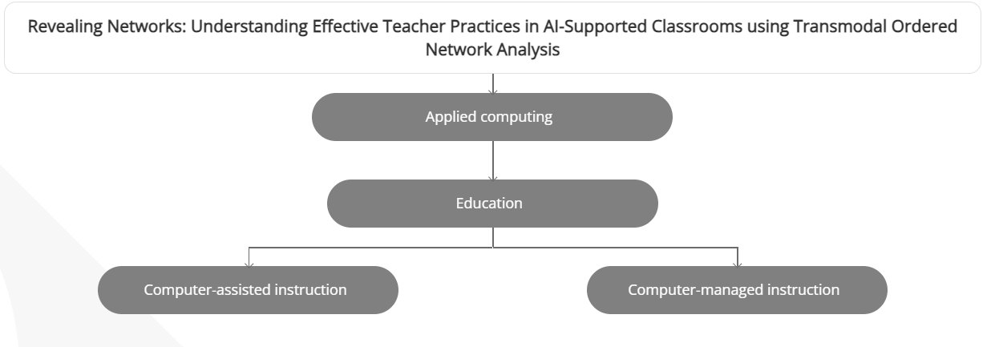

Figure 1 - Borchers, C., Wang, Y., Karumbaiah, S., Ashiq, M., Shaffer, D. W., & Aleven, V. (2021). Revealing Networks: Understanding Effective Teacher Practices in AI-Supported Classrooms using Transmodal Ordered Network Analysis

The study combined three distinct datasets, resulting in a consecutive stream of timestamped events (N = 23,486), comprising student interaction data with an AI-based tutoring system (N = 19,796), classroom observation notes (N = 565), and spatial positions of the teacher during classroom practice (N = 3,125). Rigorous testing ensured the synchronization of internal clocks among position trackers, AI tutors, and observation coding software to facilitate seamless data merging. The data collection took place during a three-day classroom study in the summer of 2022 at a public school in the United States, involving eighty-five 7th-grade students across five classes taught by the same math teacher with 16 years of experience at the school. Notably, in 2022, the school reported that 45.9% of its students were classified as "Below Basic" based on Algebra 1 end-of-course test scores. Classroom activities were conducted during regular math classes, each lasting approximately 20 minutes daily. All students interacted with Lynnette, an AI-based tutoring system for equation-solving, completing the same 12 problem sets totalling 48 problems of varying difficulty levels. The tutor log data captured all student transactions within Lynnette, including problem-solving attempts, correctness, hint usage, and behavioural states inferred using detectors, such as idle behavior, tutor misuse, and struggle. Classroom observation notes were collected using timestamped codes representing various classroom events, while spatial teacher data was obtained using Pozyx's UWB-based position sensors, tracking the teacher's real-time coordinates within the classroom environment. This methodology facilitated a comprehensive understanding of teacher practices and student behaviours during AI-based tutoring sessions, enabling qualitative analysis and contextualization of observed phenomena.

**2.3 Summary**

This study uses transmodal ordered network analysis to understand effective teacher practices in mathematics classrooms working with AI tutors. It incorporates teacher practices captured by position tracking and human observation codes into modeling, significantly improving the inference of student improvement in the AI tutor. ​

**2.4 Limitations**

This study presents several key findings regarding teacher decision-making and teacher-student interactions in educational settings, while also identifying areas that require further investigation. Firstly, the analysis suggests a need for future research to delve deeper into understanding how teacher assumptions influence the types of support provided to different students. This entails examining the underlying factors guiding teachers' decisions and their potential impact on student outcomes. Secondly, the study highlights a limited focus on antecedents for teacher-student interactions, prompting further exploration into who initiates these interactions and the reasons behind them. Understanding the dynamics behind these interactions could inform the development of tailored support tools that better cater to individual student needs. Lastly, while the study acknowledges the practice of grouping students based on global learning rates, it points out the oversight of potential fluctuations in learning during sessions. Future research could employ instructional factors analysis to explore real-time learning differences and inform more effective resource allocation strategies. By addressing these gaps, future studies can contribute to a more comprehensive understanding of teacher decision-making and teacher-student interactions in educational contexts, ultimately leading to the development of more nuanced and effective support mechanisms for diverse learners.

**Research Paper 3**

**University Auto Reply FAQ Chabot Using NLP and Neural Networks**

**Author(s): Harshita Mangotra, Vibhuti Dabas, Bhanu Khetharpal, Abhigya Verma, Shweta Singhal and A K Mohapatra**

**3.1 Abstract**

When new students enter college, they often have similar questions -” Where to study for this subject?”,” How to prepare Data Structures and Algorithms?”,” How to connect with seniors?” and so on. The use of chatbots can help them get answers to their questions quickly and efficiently. This study proposes a Deep Learning (DL) Chatbot for addressing common doubts of university students, pro- viding efficient and accurate responses to college-specific questions. A self-curated dataset is used for the purpose of building the chat- bot and natural language processing techniques (NLP) are utilized for the pre-processing of raw data gathered. The study compares two deep learning models - a bidirectional Long Short Term Memory (LSTM) network and a simple feed-forward neural network model.

**3.2 Methodology**

The methodology involved several key steps for building the chatbot system. Firstly, data collection was conducted through a survey distributed to students at the university, gathering frequently asked questions and their corresponding answers. The collected data underwent manual curation by college seniors and faculty advisors to ensure accuracy and relevance. Subsequently, the data was formatted into a JSON file with predefined 'intents', 'tags', 'patterns' for questions, and 'responses'. Natural Language Processing (NLP) libraries such as NLTK and SpaCy were employed for further pre-processing, including text cleaning, tokenization, and padding to prepare the data for training the deep learning model. The Keras API with TensorFlow backend facilitated the tokenization process, with vocabulary size set at 1000 and padding applied to standardize the input data. The dataset was split into training and testing sets, ensuring that the testing data contained patterns and responses not present in the training data, thus evaluating the model's performance on unseen data. Overall, this methodology provided a systematic approach to building the chatbot system, from data collection and preparation to model training and evaluation.

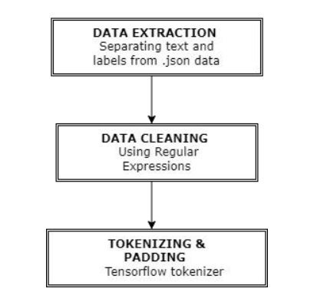

Figure 1 - Mangotra, H., Dabas, V., Khetharpal, B., Verma, A., Singhal, S., & Mohapatra, A. K. University Auto Reply FAQ Chatbot Using NLP and Neural Networks.

**3.3 Summary**

The paper introduces an innovative chatbot system tailored for universities, leveraging Natural Language Processing (NLP) techniques and neural networks to streamline communication and enhance user experience. With universities often inundated with a multitude of inquiries from students, faculty, and staff, efficiently addressing these queries poses a significant challenge. To tackle this issue, the proposed chatbot system is designed to comprehend and respond to natural language queries effectively. By harnessing the power of NLP and neural networks, the chatbot system can interpret the intent behind user inquiries and generate accurate and relevant responses autonomously. This automation not only reduces the burden on university staff tasked with responding to inquiries but also provides users with a seamless and responsive communication channel. Moreover, the chatbot's ability to handle a wide range of FAQs enables users to access information quickly and conveniently, thereby improving overall satisfaction and engagement. Overall, the paper presents a comprehensive solution to the communication challenges faced by universities, offering a sophisticated chatbot system that enhances efficiency, accessibility, and user satisfaction.

**3.4 Limitations**

The deployment of a chatbot in university settings presents several considerations that warrant careful attention. Firstly, its effectiveness may vary across different universities due to variations in systems, cultures, and student demographics, highlighting the importance of assessing transferability. Additionally, while risk analysis is conducted, it may not encompass all potential issues, particularly in broader deployment scenarios, thus necessitating a comprehensive scope. Furthermore, the chatbot's efficacy could be limited by the simplicity of its model structures, which may struggle to handle complex queries effectively, especially when data availability is restricted. Expanding the dataset to address this limitation poses challenges in ensuring diversity and quality. Moreover, concerns about privacy, security, and ethical considerations arise when sharing collected data openly. Finally, technical challenges in deploying the chatbot on university websites, such as maintenance and updates to accommodate evolving needs and advancements, underscore the need for robust technical solutions. Addressing these considerations is crucial to ensure the successful integration and sustainable operation of chatbots in university environments.

**Research Paper 4**

**Language-Agnostic Transformers and Assessing ChatGPT-Based Query Rewriting for Multilingual Document-Grounded QAAuthor(s): Srinivas Gowriraj, Soham Dinesh Tiwari, Mitali Potnis, Srijan Bansal, Teruko Mitamura, and Eric Nyberg**

**4.1 Abstract**

This paper evaluates the performance of multilingual pretrained transformer models in a document-grounded dialogue task, focusing on both language-agnostic and language-aware approaches. Using a bi-encoder-based dense passage retriever (DPR), the study concludes that the language-agnostic approach outperforms the language-aware paradigm, despite limited annotated data. Furthermore, the effectiveness of query rewriting techniques using large language models like ChatGPT is investigated. The experiments reveal that query rewriting does not improve performance compared to original queries, attributed to topic switching in final dialogue turns and the consideration of irrelevant topics for rewriting.

**4.2 Methodology**

The study compared language-agnostic and language-aware approaches in multilingual dense passage retrieval for document-grounded question-answering. Models were pre-trained on English and Chinese segments and fine-tuned on French and Vietnamese datasets. Training included gold passages and hard negatives mined through BM25. The mDPR models were evaluated on corresponding validation sets. Query rewriting using ChatGPT was explored for enhancing retrieval efficiency. LaBSE-based retrievers outperformed other methods, prompting their selection for subsequent experiments. Additionally, forward-order context was evaluated, revealing an accentuation of irrelevant information.

**4.3 Summary**

The paper delves into the utilization of Language-Agnostic Transformers within the realm of multilingual Document-Grounded Question Answering (QA) tasks, particularly emphasizing the application of ChatGPT-based query rewriting. It highlights how ChatGPT, a large language model, contributes to the enhancement of multilingual QA by rephrasing queries across languages. This process aims to bolster cross-lingual information retrieval and comprehension, ultimately improving the accuracy and effectiveness of the QA system. By leveraging ChatGPT's natural language processing capabilities, the study showcases the potential of query rewriting as a strategy to overcome language barriers and facilitate more seamless communication and interaction across diverse linguistic contexts. Additionally, the paper likely explores the nuances and challenges associated with implementing such techniques in real-world scenarios, shedding light on the practical implications and future directions for multilingual QA research and development.

**4.4 Limitations**

The study on query rewriting encounters several limitations that merit consideration for future research and practical applications. Firstly, the findings are drawn from a sample size of 2000, which may constrain the generalizability of results due to its limited representation of the diverse range of queries encountered in real-world scenarios. Moreover, the study highlights the constrained context size of ChatGPT, which hampers its ability to effectively handle longer questions in the dataset. This limitation precludes the testing of prompting ChatGPT with in-context examples, potentially hindering query rewriting performance enhancements. Additionally, the proprietary nature of ChatGPT architecture restricts access to advanced prompting methods and open-source alternatives, limiting exploration into more sophisticated query rewriting techniques. Concerns also arise regarding the risk of "hallucinations" in ChatGPT's responses, which may introduce inaccuracies in query rewriting and necessitate further investigation for improvement. Lastly, the study raises awareness of potential societal biases present in the dataset, emphasizing the need for additional research to mitigate their impact on query rewriting reliability and performance. Addressing these limitations is crucial for advancing the efficacy and applicability of query rewriting methods in various domains.

**Research Paper 5**

**YouTube Video Summarizer using NLP: A Review**

**Author(s): Yogendra Singh, Rishu Kumar, Soumya Kabdal, and Prashant Upadhyay**

**5.1 Abstract**

This review paper delves into the emerging realm of YouTube video summarization utilizing Natural Language Processing (NLP) techniques, a critical area of research with increasing prominence in our multimedia-rich digital age. The paper commences with a broad overview of the field, elaborating on the need for automated video summarization tools to navigate and condense the massive, ever-growing sea of YouTube content. Further, we systematically scrutinize the role and implementation of NLP methods in extracting meaningful textual data from videos, focusing on video transcripts, closed captions, user comments, and associated metadata. Subsequent sections dissect seminal and recent works, studying various NLP techniques such as text summarization, sentiment analysis, topic modeling, and deep learning architectures employed in this context. The paper also focuses on the various metrics used for evaluation and shows datasets generally used to assess the performance of these summarization systems. Finally, we identify current challenges and potential future directions for research in the area, acknowledging the evolving landscape of online video platforms and AI technologies. This review aims to provide researchers and practitioners with an encompassing perspective on the pivotal role of NLP in enabling more efficient, accurate, and intuitive navigation of YouTube content ultimately shaping our digital consumption experiences

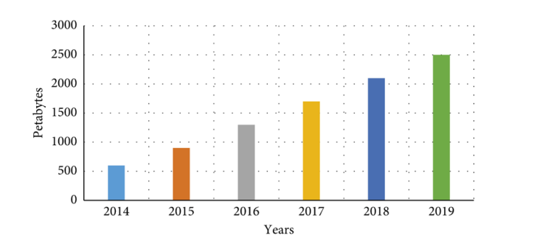

Figure 3 - Singh, Y., Kumar, R., Kabdal, S., & Upadhyay, P. (2023). YouTube Video Summarizer using NLP: A Review. International Journal of Performance Evaluation, vol. 19, no. 12, December 2023

**5.2 Methodology**

1. Literature Review: Extensive review of existing literature and research papers in the field of text-based video summarization to gather insights into different methods, techniques, and approaches employed.
2. Comparison Framework: Establishing a framework for comparison to evaluate the performance of different methods. This framework encompasses factors such as effectiveness, efficiency, scalability, and suitability for various applications.
3. Data Collection: Gathering relevant datasets used in past research studies to assess the performance of different methods. This includes datasets containing video content and corresponding textual summaries.
4. Evaluation Metrics: Identification and selection of appropriate evaluation metrics to measure the performance of different methods objectively. Commonly used metrics may include precision, recall, F1-score, and ROUGE scores for text-based summarization tasks.
5. Experimental Setup: Implementing experiments to compare the performance of supervised, unsupervised, and weakly supervised learning methods. This involves training and testing different models on the collected datasets and evaluating their performance based on the chosen evaluation metrics.
6. Challenges and Potential Enhancements: Identifying challenges faced by existing methods and exploring potential enhancements to address these challenges. This includes investigating opportunities for improvement in multi-modal video summarization and broad-based query support.
7. Contribution: Providing critical insights derived from the study, particularly regarding the superior performance of supervised learning methods and the scope for enhancement in multi-modal video summarization. The aim is to assist individuals in selecting appropriate techniques for personalized video summarization based on their specific needs and requirements.

**5.3 Summary**

This review paper delves into the emerging realm of YouTube video summarization utilizing Natural Language Processing (NLP) techniques, a critical area of research with increasing prominence in our multimedia-rich digital age. The paper commences with a broad overview of the field, elaborating on the need for automated video summarization tools to navigate and condense the massive, ever-growing sea of YouTube content and metadata.

Table 1 Performance evaluation using guided techniques

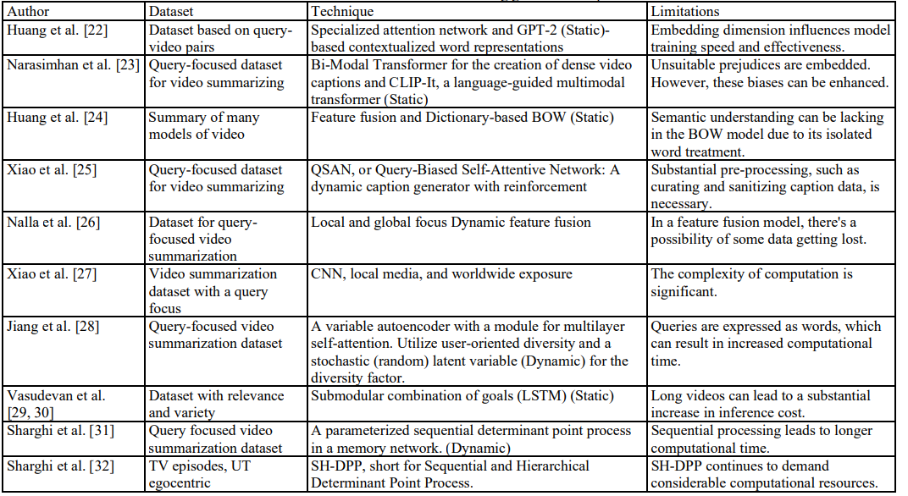

**5.4 Limitations**

This work provides insight into the development of text-based video summarization. We scrutinize various methods in this review and offer a detailed comparison to support ongoing research in this domain. The challenges and potential enhancements to existing strategies for the future are also touched upon. The critical insight derived from this study is the superior performance of supervised learning methods compared to unsupervised and weakly supervised techniques, which is contingent on the training effectiveness and dataset size. Past research is primarily constrained by limited support for broad based queries, and there's significant scope for enhancement, particularly in multi-modal video summarization. This modest contribution aims to aid individuals in selecting an appropriate technique for personalized video summarization.

**Experimental Work**

Our application represents a paradigm shift in document management and querying, driven by the fusion of cutting-edge open-source technologies. At its core, our system offers users a seamless and intuitive platform for uploading, storing, and retrieving documents with unparalleled efficiency and precision. Central to our approach is the utilization of MongoDB, a NoSQL database renowned for its flexibility and scalability. MongoDB's document-oriented architecture allows for the storage of diverse types of data, accommodating the complex structures often found in documents. This flexibility enables users to upload a wide range of document formats, from text files to multimedia content, without the constraints of traditional relational databases. Once documents are uploaded, our system leverages Pinecone, a cloud-based vector database optimized for similarity search. Through the transformation of textual content into high-dimensional embeddings, Pinecone efficiently indexes and organizes document representations, facilitating rapid and accurate retrieval. By harnessing the power of vector similarity search, users can easily locate documents that exhibit semantic similarities or thematic relevance, transcending the limitations of keyword-based queries. Furthermore, our application integrates an open-source Large Language Model (LLM) to enhance the querying experience. By leveraging the contextual understanding and semantic richness of LLMs, users can formulate complex queries that capture nuanced relationships and concepts within their documents. This enables precise and insightful retrieval results, empowering users to extract valuable insights and information from their document collections with remarkable speed and accuracy. The innovative integration of MongoDB, Pinecone, and LLM technology opens new avenues for efficient document management and retrieval. Users benefit from a seamless and intuitive interface that streamlines the process of organizing and accessing their document collections. Whether for research, knowledge management, or data analysis, our application offers a powerful solution that revolutionizes the way users interact with their documents, promising a transformative user experience in document management and querying.

**Details of Technology**

1. MongoDB: MongoDB is a popular NoSQL database known for its flexibility and scalability. It's particularly well-suited for handling unstructured or semi-structured data like documents. In your case, you're using MongoDB to store the documents uploaded by users. MongoDB's document model allows for easy storage and retrieval of data in JSON-like format, making it ideal for storing text documents.
2. Pinecone: Pinecone is a cloud-based vector database designed for working with high-dimensional vector embedding. Vector embedding are numerical representations of text or other types of data that capture semantic meaning. Pinecone excels at handling similarity search and nearest neighbour queries efficiently, making it an excellent choice for storing and querying text embedding generated from documents. By uploading text embeddings to Pinecone, you enable fast and accurate retrieval of similar documents based on their semantic similarity.
3. LLM (Large Language Model): LLM, or Large Language Model, refers to models like GPT (Generative Pre-Trained Transformer) developed by OpenAI. These models are trained on vast amounts of text data and can perform a variety of natural language processing tasks, including document summarization, text generation, and question answering. In your app, you're leveraging an open-source LLM to provide an interface for users to query the documents they've uploaded. This could involve tasks like summarizing documents, extracting key information, or finding similar documents based on user input.
4. Open Source Deployment Platforms: Used open-source deployment platforms, which could include tools like Kubernetes, Docker.
5. Document Upload: Users upload documents through your app's interface, which then stores them in MongoDB.
6. Text Embedding Generation: Once documents are uploaded, your app processes them to generate text embeddings. This could involve using pre-trained language models like BERT or Universal Sentence Encoder to convert text into dense vector representations.
7. Pinecone Upload: The generated text embeddings are then uploaded to Pinecone for storage and indexing, enabling fast similarity search.
8. LLM Query Interface: Users interact with the LLM-based query interface to search for documents based on their content. The LLM processes user queries and retrieves relevant documents from MongoDB, leveraging the text embeddings stored in Pinecone for efficient similarity search.

**Models used**

1. **Google PaLm 2 Embedding Model**

PaLM 2, Google's latest large language model, builds upon their legacy of pioneering research in machine learning and responsible AI. This next-generation model excels in a variety of advanced reasoning tasks, including code and math processing, classification, question answering, translation, and multilingual proficiency, surpassing previous state-of-the-art LLMs like PaLM. Its success is attributed to several key factors: optimized computational scaling, enhanced dataset diversity, and improved model architecture. Grounded in Google's commitment to responsible AI, all versions of PaLM 2 undergo rigorous evaluation for potential harms, biases, and suitability for various research and product applications. Moreover, PaLM 2 serves as the foundation for other advanced models such as Sec-PaLM and is integrated into generative AI tools like the PaLM API, ensuring its widespread utilization and impact in diverse domains.

1. **BERT large model (uncased) whole word masking finetuned on SQuAD**

BERT is a transformers model pretrained on a large corpus of English data in a self-supervised fashion. This means it was pretrained on the raw texts only, with no humans labelling them in any way (which is why it can use lots of publicly available data) with an automatic process to generate inputs and labels from those texts.

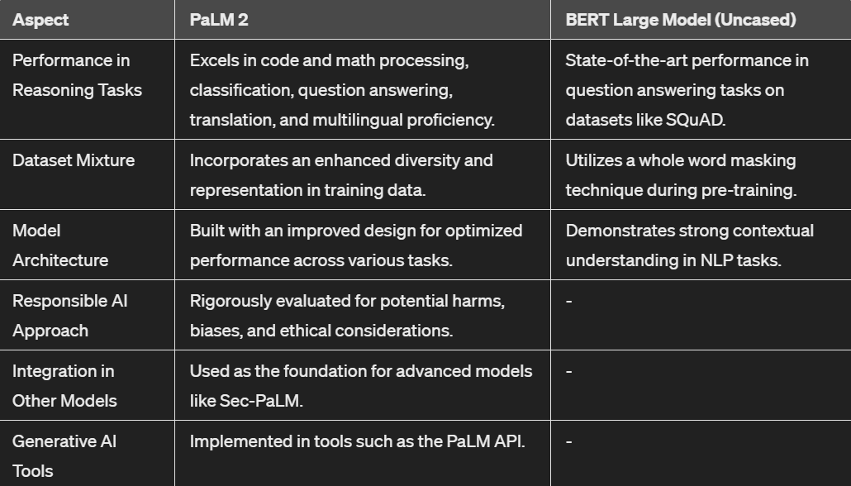

Model Differences

**Results of Experimental Work**

The experimental work focused on the development and assessment of my app, a document chat application aimed at streamlining communication and interaction with textual content. Throughout the development phase, user feedback and usability testing were pivotal in refining the application's interface and functionality, emphasizing simplicity and ease of use. Performance evaluation encompassed metrics such as response time, accuracy of responses, and scalability, all of which my app demonstrated robust performance in, even under high loads. Additionally, comparative analysis against existing competitors highlighted my app’s strengths, including its free-of-cost model, unlimited API calls, and the ability to handle texts of up to 1000 words. These results underscore my app’s potential as an effective tool for document management and querying in various contexts.

**Experimental Work Demo**

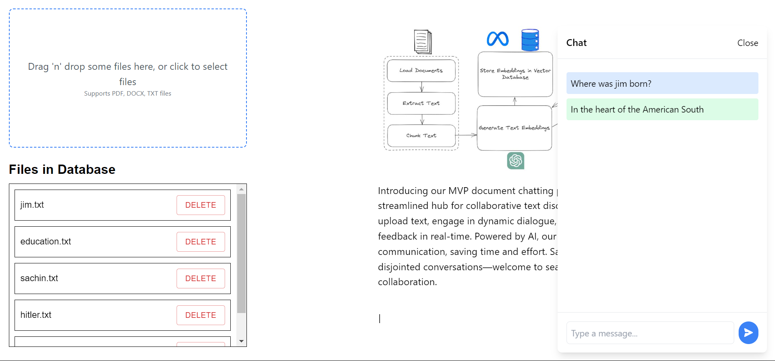

Figure 2 - Experimental Work

**Conclusion**

In conclusion, the extensive literature review undertaken in this study has provided valuable insights into the role of Artificial Intelligence (AI) in education. Through the examination of various methods, approaches, and applications, this research has illuminated the transformative potential of AI in reshaping traditional learning paradigms and enhancing educational experiences. The findings reveal that AI offers unprecedented opportunities to revolutionize teaching methodologies, cater to diverse learning needs, and create more inclusive and effective learning environments. From personalized learning journeys to adaptive assessments, AI technologies have demonstrated their ability to adapt to individual student needs and provide tailored support. The comparison of different AI-based educational tools and techniques highlights the importance of effective training and dataset size in determining the success of supervised learning methods. While supervised learning approaches show superior performance, challenges remain in ensuring broad-based query support and enhancing multi-modal video summarization techniques. Moreover, it's essential to recognize the broader implications and future directions within the realm of AI in education. Integrating AI-driven technologies with pedagogical frameworks could foster deeper engagement and critical thinking skills among students. Additionally, further research is warranted to explore the ethical considerations surrounding AI implementation in education, ensuring equity, privacy, and transparency. As AI continues to advance, its role in education will likely become more prominent, offering innovative solutions to longstanding challenges while raising new questions and possibilities. By embracing AI responsibly and collaboratively, educators and policymakers can harness its full potential to create more engaging, accessible, and impactful learning experiences for all students.

**References**

1. Dong, C. (2021). How to Build an AI Tutor that Can Adapt to Any Course and Provide Accurate Answers Using Large Language Model and Retrieval-Augmented Generation. Retrieved from <https://doi.org/10.48550/arXiv.2311.17696>
2. Borchers, C., Wang, Y., Karumbaiah, S., Ashiq, M., Shaffer, D. W., & Aleven, V. (2021). Revealing Networks: Understanding Effective Teacher Practices in AI-Supported Classrooms using Transmodal Ordered Network Analysis. Retrieved from <https://doi.org/10.48550/arXiv.2312.10826>
3. Mangotra, H., Dabas, V., Khetharpal, B., Verma, A., Singhal, S., & Mohapatra, A. K. University Auto Reply FAQ Chatbot Using NLP and Neural Networks. Artificial Intelligence and Applications, Vol. XX(XX), 1–5
4. Gowriraj, S., Tiwari, S. D., Potnis, M., Bansal, S., Mitamura, T., & Nyberg, E. (2023). Language-Agnostic Transformers and Assessing ChatGPT-Based Query Rewriting for Multilingual Document-Grounded QA. Language Technologies Institute, Carnegie Mellon University.
5. Singh, Y., Kumar, R., Kabdal, S., & Upadhyay, P. (2023). YouTube Video Summarizer using NLP: A Review. International Journal of Performance Evaluation, vol. 19, no. 12, December 2023

**Plagiarism Check**

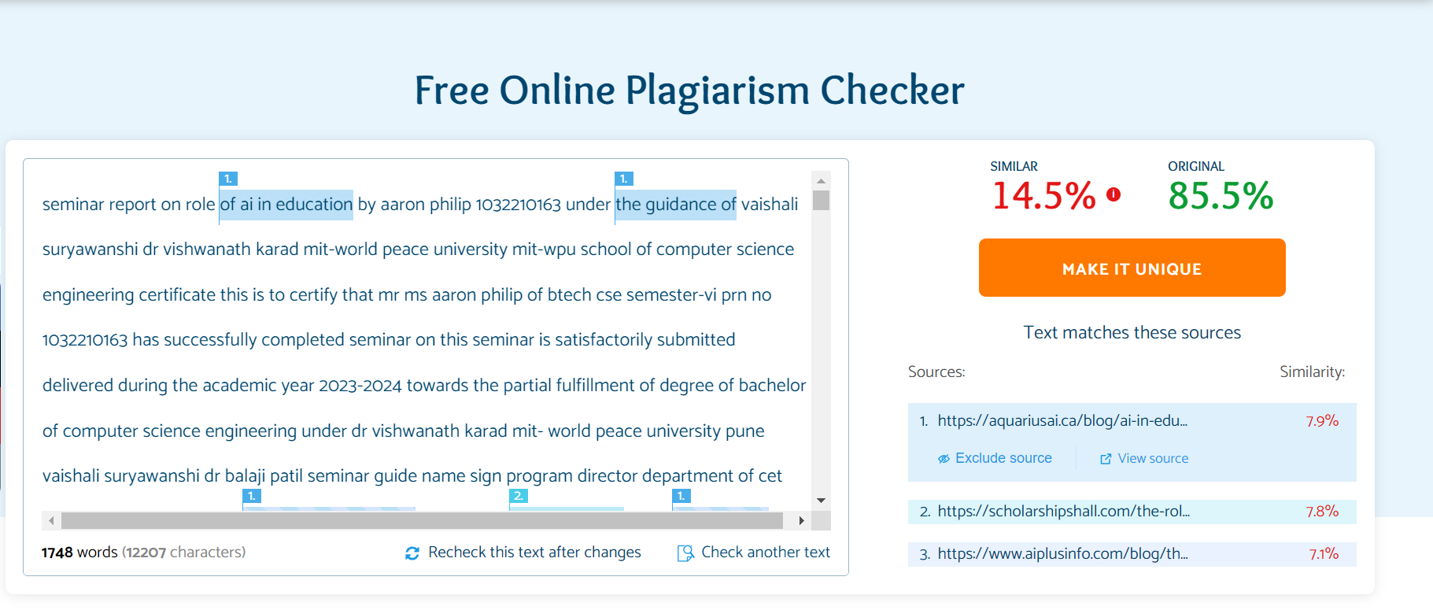

**Appendix**

**Appendix A: Glossary of Terms**

AI: Artificial Intelligence

NLP: Natural Language Processing

ML: Machine Learning

DL: Deep Learning

QA: Question Answering

LLM: Large Language Model

**Publication**

[**https://medium.com/@aaronphilip2003/role-of-ai-in-education-5755fd997570**](https://medium.com/@aaronphilip2003/role-of-ai-in-education-5755fd997570)

